Laser Pointer Calculations

# Introduction

The following provides an exact solution to the problem to determining the servo angles necessary to locate the laser pointer used in the ACT and VISION labs for Robotics I 2014.

# For the X, horizontal direction

The grid space is X by Y where X is the number of columns and Y the number of rows. For an image, the 0, 0 location is the top left with X increasing to the right and Y increasing downward.

To move the laser pointer to a specific grid location, start with an overhead view, that of a quad-copter.

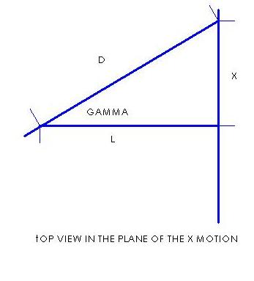

The solution in the forward direction, solving for X, is below where L is the distance from the laser pointer center of rotation to the bulletin board and gamma, γ, is the rotation of the X axis servo.

X = L * TAN (γ) and D = L / COS (γ)

In the reverse direction:

γ = ATAN (X/L)

# For the Y, vertical direction

Next, for the Y direction, below is a diagram of the view of the plane of gamma, γ, from above:

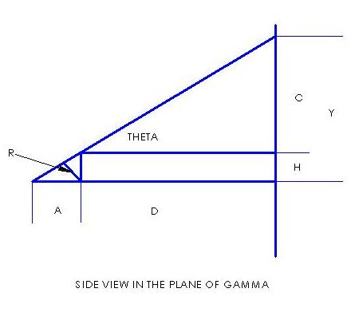

Here, D is the value obtained from the X direction calculation, R is the radius of rotation of the Y axis servo, theta, θ.

In the forward direction, solving for Y:

Y = (D * SIN (θ) + R) / COS (θ)

The reverse direction is more difficult, however:

Θ = ATAN(Y/D) – ATAN [R / ((Y^2 + D^2 –R^2) ^0.5))]